**Please fill this questionnaire**

**1) How do you describe your business/yourself?**

Our business focuses on generating electrical energy from natural H2O from precipitation and snow to create a stronger adaptation to climate change, concurrently avoiding some financial recoil that would normally be taken to produce the electrical power gained by our system. Using concepts of hydroelectric power, our renewable energy can provide the user with 100 Watts of electricity for every 300 Joules of harvested potential energy from natural water runoff.

**2) What is the primary goal of your website?**

The primary goal of our website is to increase awareness of our technology for public and private commercial consulting in order to convince clients to implement our Renewable Energy System using Hydropower. The website displays information regarding the contents of the technology that can be available to consumers upon installation in their houses.

We are assuming customers may have problems with access to water and/or electrical energy in this hard economy world and climate change and could benefit from an implementation of our commercial renewable energy system. Nevertheless, our system can be implemented by several other customers that may have an interest in saving financial assets that correspond to daily electrical and water needs. From the implementation of this technology, we can provide more services to help customers save financial assets regarding daily electrical maintenance (e.g. lighting, heating, water irrigation).

**3) What problem do you want to solve with this design?**

There are several problems that our renewable energy system can introduce solutions and or relief to the problems of our product consumers. These includes, but is not limited to the following potential problem(s):

* **The problem of** not having enough financial resources to access water from the usual water distribution networks available to households by their fellow government.
  + The implementation of our system will allow a “cut off” of services that would normally require financial assets to bring, such as paying for electrical services.
* **The problem of** being negatively impacted by hazards due to climate changes, such as house isolation from heavy snow storm buildup or floods due to heavy rain storms.
  + In the case of snow: The snow that would accumulate in houses could be melted with our system’s thermal components and defrosted to liquid water solution for storage and future use.
  + In the case of heavy storms, a percentage of water that would normally start to flood into public drainage would be collected and stored for each household with our device and used by the house members in the near future.
* **The problem of** lack of access to electricity in households that would normally be necessary for daily uses (e.g. lighting, electric stove/ovens, phone or other essential electrical appliances).
* **The problem of** increasing daily food supplies at commercial premises.

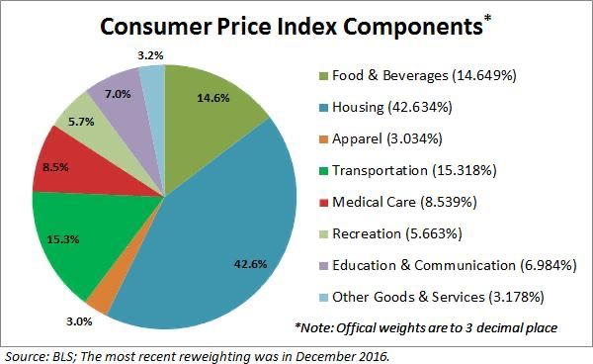

**4) Who are you competitors or references (their website links)?**

1. [Raindrop Electricity: Generating 'Blue Energy' from Rainfall](https://www.discovery.com/science/raindrop-electricity--generating--blue-energy--from-rainfall)
2. [New Way to Generate Electricity From Rain Can Power 100 LED Bulbs Per Drop](https://www.sciencealert.com/we-re-getting-closer-to-generating-electricity-from-raindrops)
3. [ps](https://www.sciencealert.com/we-re-getting-closer-to-generating-electricity-from-raindrops)[SCIENTISTS INVENT DEVICE TO GENERATE ELECTRICITY FROM RAIN](https://futurism.com/the-byte/generate-electricity-rain)
4. [How Much Power Can We Get from Raindrops? | Inside Science](https://www.insidescience.org/news/how-much-power-can-we-get-raindrops)
5. [Pictures searched by rain energy generator models blue print](https://www.google.com/search?q=rain%20energy%20generator%20models%20blue%20print&tbm=isch&tbs=rimg:CQeHmhAApNOEYbNlY8Nx1Bid&bih=626&biw=1301&hl=en&sa=X&ved=0CAIQrnZqFwoTCLjn7vL88e4CFQAAAAAdAAAAABAG)
6. [Pictures searched by rain energy generator models blue print](https://www.google.com/search?q=rain+energy+generator+models+blueprint&tbm=isch&hl=en&sa=X&ved=2ahUKEwiXqZ7x_PHuAhULdXAKHeA8AWQQBXoECAEQLQ&biw=632&bih=600)
7. [Renewable Energy Hub](https://www.renewableenergyhub.us/rainwater-harvesting-information/)

**5) Do you have the content ready for your website (logo + text content)?**

**Flyer (Part 1): Ken & Adolfo**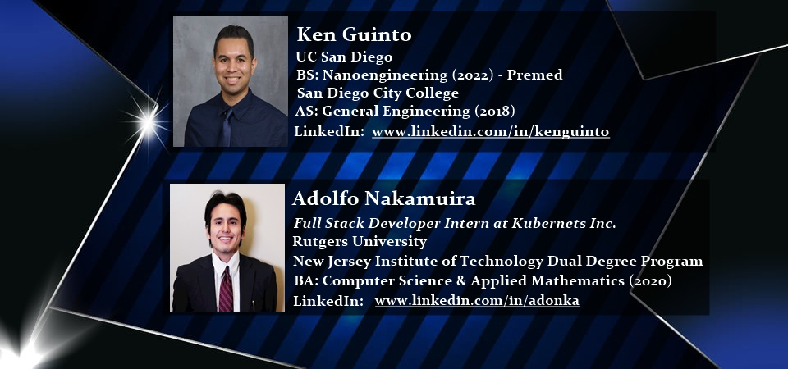

**Flyer (Part 2): Onel & Filiberto (In progress)**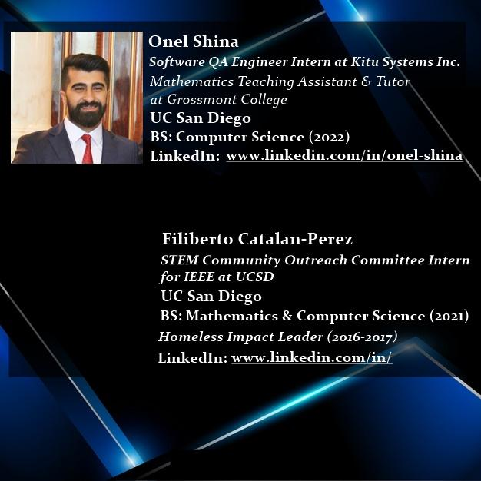

**6) What are the demographic of your customers/users?**

wealth family whose house income is more than 5,000,000 yens

**Appeal to Households with SNOW environments:**

1. 札幌、北海道、日本｜Sapporo, Hokkaido, Japan
2. 京都府、日本｜Kyoto, Japan
3. Chicago, Illinois, USA
4. Ann Arbor, Michigan, USA
5. Princeton/New Brunswick/Newark, New Jersey, USA
6. New York City, New York, USA
7. Vancouver, Canada

**Appeal to Households with Rain environments:**

1. Seattle, Washington, USA
2. Davis/Sacramento/Stocktown, California, USA
3. Portland, Oregon, USA
4. Bombay/New Delhi, India

**7) What impression do you want to give your users when they see your website for the first time?**

The impression that we would expect for visitors of our website to have is that “an innovative technology for Renewable Energy has arrived that allows benefits to be extracted from the natural water cycle to generate electricity and water in a safely, environmentally-friendly, and economically affordable manner.

**8) What information your users will be looking for on your website?**

1. Description of the project, service, tools, office, blog
2. How much water and electricity bills are saved.
3. How much water is stored.
4. How much energy is generated.
5. When is the generator checked by engineers?
6. Estimation of the amount of electrical energy (V) and water volume (L) they will have.
7. Send text messages when we have to change any parts of the generator, such as the battery.
8. How the water can be used after filtering aside from drinking water since this requires additional detailed filtration processes.
9. Clean water for you pets and plants.
10. How many lives may be saved from now on from the benefits of our system’s mechanical work to electrical power
11. How we including pets can be healthy by using this filtered water.( storing and planting veggies)

**Please fill and/or organize each section**

Title: Energy Harvesting from Rainwater and Snow - SD Hacks

# Section 1: Electrical Generation & Water Storage

## Headline: Intro to Rainwater Harvesting using Hydropower Technology

### Sub-headline: What is the problem & why we solve this problem

First paragraph

Our business focuses on utilizing a thermo filtration system for harnessing energy from natural H2O from precipitation and snow to create a stronger adaptation to climate change, concurrently avoiding some financial recoil that would normally be taken to produce the electrical power gained by our system.

Button: Demo

Embed this Youtube Link Somewhere in the Website:

<https://www.youtube.com/watch?v=aD8ut50QMx8>

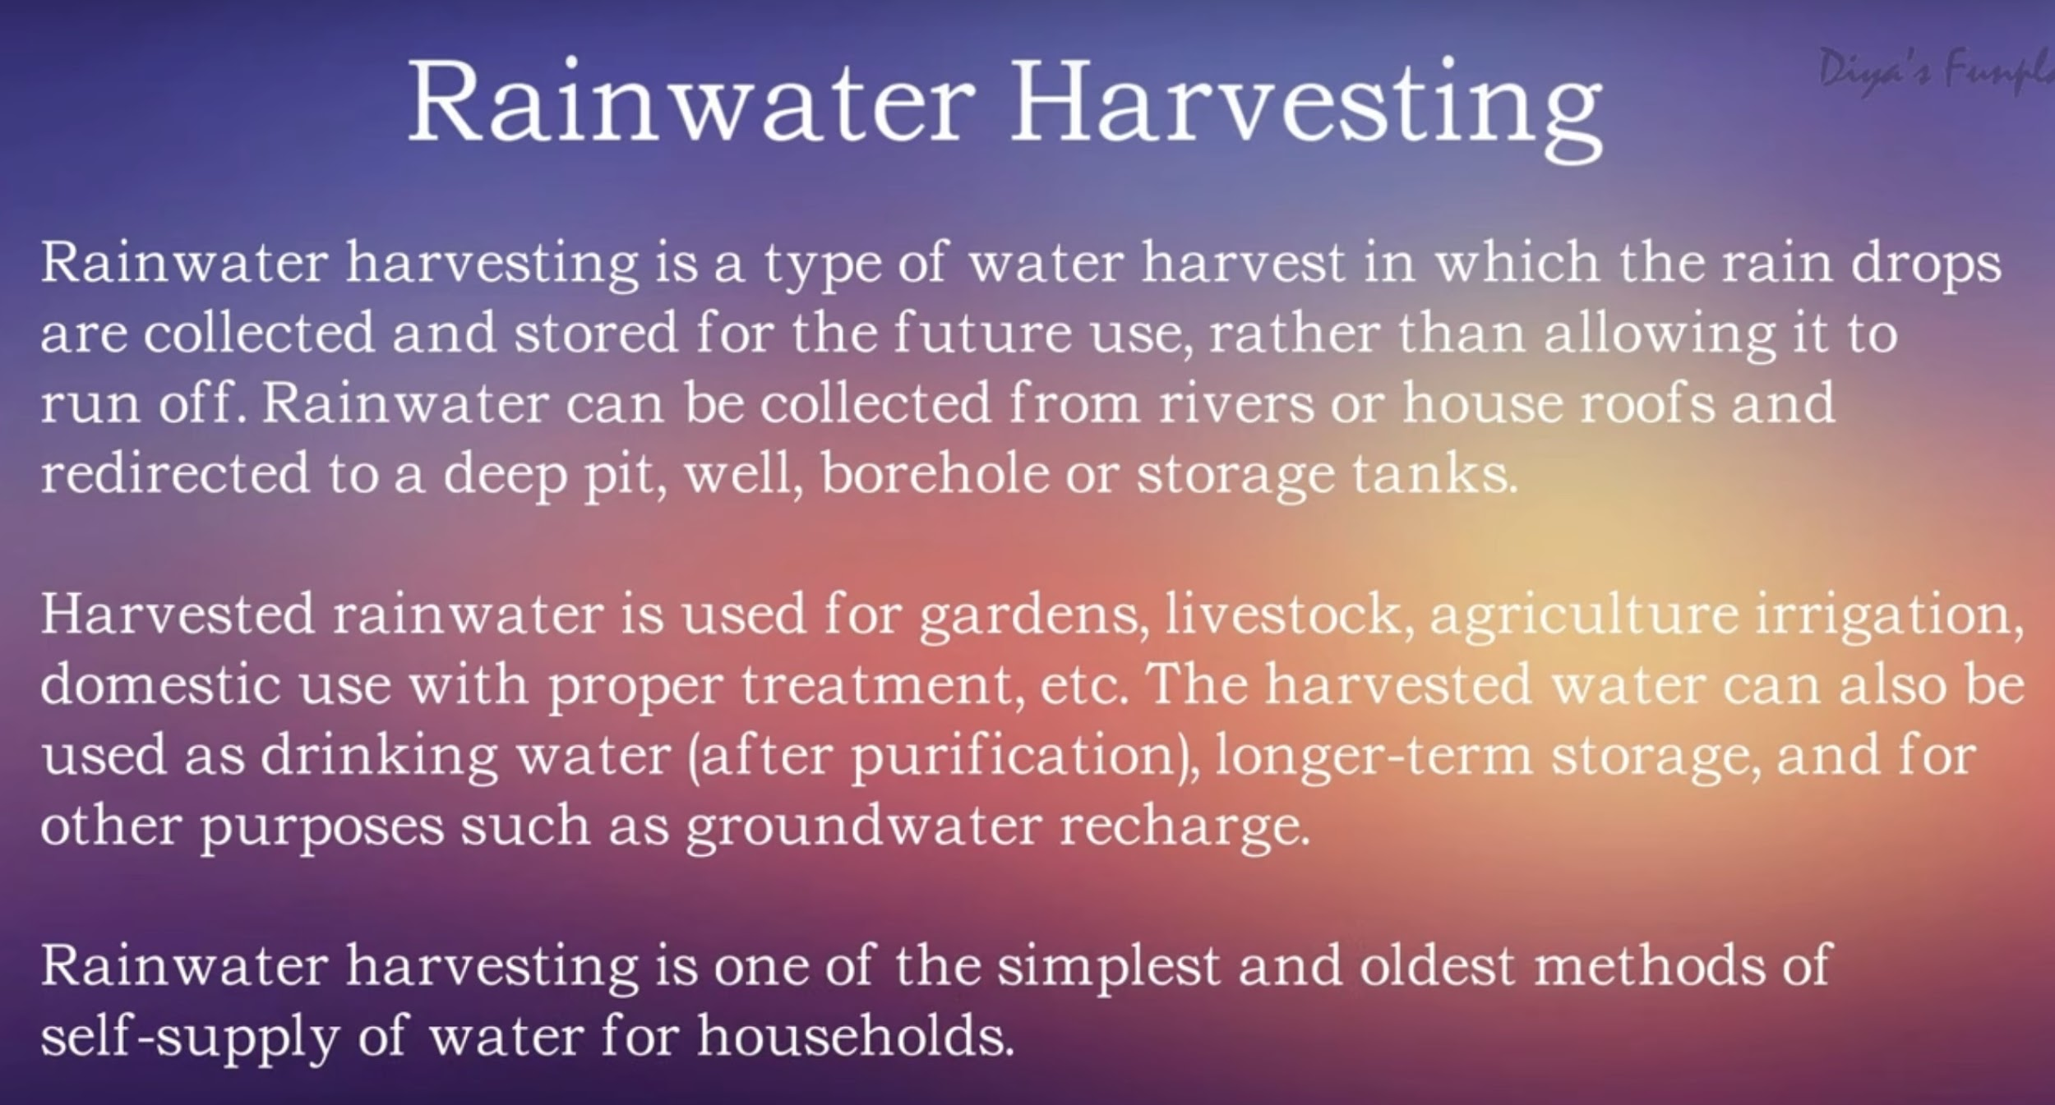

# 

# Section 2: How can we do this?

## Heading: How to create

### Subheading: Materials we need

1. Steper Motors

2.

3.

4.

### Subheading: Methods we need

1. Temperature

2. Biochemical Filter

3.

### Subheading: Machines we need

1. Filters

2. Elecctrca

3.

4.

# 

# Section 3: Profile

## **Heading: Team Members**

### **Subhead: Ken Guinto**

Links, titles and details of all the projects

UC San Diego

BS: Nanoengineering - Bioengineering Focus (2022)

San Diego City College

AS: General Engineering(2018)

LinkedIn: <https://www.linkedin.com/in/kenguinto>

### **Subhead: Adolfo Nakamura**

Links, titles and details of all the projects

Full Stack Developer Intern at Kubernets Inc.

Rutgers University - Newark

BA: Computer Science & Applied Mathematics (2020)

LinkedIn: <https://www.linkedin.com/in/adonka>

### **Subhead: Onel Shina**

Links, titles and details of all the projects

Software QA Engineer Intern at Kitu Systems, Inc.

UC San Diego

BS: Computer Science (2022)

LinkedIn: <https://www.linkedin.com/in/onel-shina/>

**Subhead: Filiberto Catalan-Perez**

Links, titles and details of all the projects

UC San Diego

BS: Mathematics & Computer Science (2021)

LinkedIn:

# 

# Section 4: What language we are using

## Heading: Technical Skills and Programming Skills

### Subheading: Frameworks: Flask

### Subheading: Programming skills: Python

### Subheading: Software: Webflow

Footer

Heading

Subheading:

Button

Social Links

Facebook →

Twitter →

Instagram →

LinkedIn →

Our Fancy office

Email: example@ex.com

Phone: 9999999999

Check the

<https://www.figma.com/file/nib4HrCgXWQexNqgO8wnlH/Clean-Water-Access?node-id=1%3A3>

UX/UI

## Business Objective

### Business Requirement

#### What are the goals for creating the clean water access app?

One of our goal is to increase the users of this service.

#### What does success look like? How will we know when we have been successful?

People find a new way to generate energy and save money with this app.

#### Who are the users of the site?

Homeless? Immigrants? Students? Real estates investors? Real Estate Agents? Engineers?

#### Why would they use this productor service? What problems are they having that we ca solve?

Reduces your water bill. Decreases the demand for water. Promotes water and energy conservation. Improves the quality and quantity of groundwater level. Rainwater has all the necessary nutrients for plants and agriculture. Rainwater harvesting is relatively simple, easy to install and operate. It reduces sol erosion, storm water runoff, flooding, and pollution of surface water with fertilizers, pesticides, metals and sediments. Reduces your electricity bill for pumping water up from a borewell. It is an excellent source of water for vegetable gardens with no chemicals and dissolved salts and fee from all minerals.

## User Research

### Empathy Map

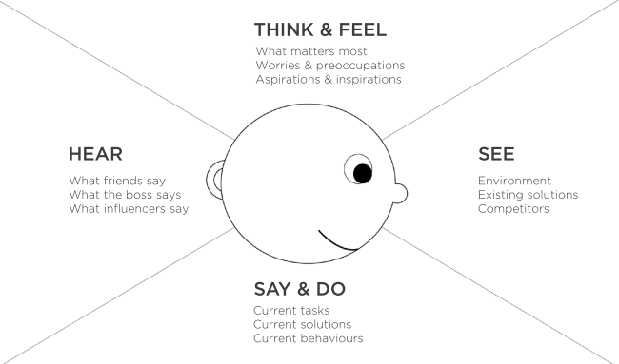

#### **THINK & FEEL: What matters most Worries & preoccupations Aspirations & inspirations**

1. The desire to save money as much as possible, but there is no budget cut any more.
2. The uncertainty of not knowing how much money users can save
3. The uncertainty of not knowing if they really can benefit from the water that is stored (e.g. irrigation, water supply, drinkable, higiene)
4. How does it work? What types of rainwater harvesting system do we have?
5. The energy generated by the service is not a lot. It costs a lot to install the collection system and the various filters. Hence, what is the right installer for me? Is the system worth it?
6. The uses of rain water harvesting.
7. How much does it cost for the maintenance and warranties?
8. The feasibility factor of the innovative renewable energy system may be low.
9. What harvesting tanks, equipment and kits can we have?
10. How long would it take to fix any issues that may arise due to technical difficulties of this new technology?
11. What is the durability factor of this system (e.g. how many years is it good for)?
12. What is the hazard effect score of the snow and water is higher than the maximum threshold that this renewable energy is capable of handling at functional regularability?
13. How much time do I have to spend tracking any changes or management of the system outside of the scope of its natural automatization capabilities?

#### HEAR What friends say? / What the boss says? / What influencers say?

1. Clean energy is important or amazing!
2. That user must be saving money from that innovative approach to energy harvesting.
3. We can generate energy from this as long as water keeps cycling.
4. That house owner must be very environmentally friendly
5. That system must have cost that person a fortune.
6. What would happen if any of those gadgets were to malfunction?

#### SEE Environment / Existing solutions Competitors

**Problem (environmental hazard in the form of SNOW) vs Solution**

|  |  |
| --- | --- |
| **Problem** | **Device Potential Relief** |
| Hokkaido’s Snow in Domestic Houses (Japan) | Snow Melter and Shelving Machine to avoid forced in-home isolation due to natural cause |
| Chicago’s Snow in Domestic Houses and Airport Terminals (USA) | The use of this device now allows Chicago residents the ability to clear their homes from the snow and convert that snow into electrical power.  External Link: <https://chicago.cbslocal.com/video/5321600-snow-being-cleared-to-avoid-dibs/> |
| Vancouver’s Snow in Domestic Houses and Airport Terminals (Canada) | Transportation Delay at International Airport Terminals Due to Snow sometimes occur in Vancouver as it is a hub for aero transportation deplane of international and domestic flights. Our devices can be used to clear these snow on terminals, concurrently supplying water and electrical power to the airport for heating and other important hygiene purposes. |
| Snow storms | Storm Alerts |
| Lack of Water | Buy a water pack. Buy medicine to clean dirty water. |
|  |  |

**Problem (environmental hazard in the form of RAIN) vs Solution**

|  |  |
| --- | --- |
| **Problem** | **Device Potential Relief** |
| Flooding | Evacuation, flood insurance, flood prevention systems |
| Seattle, Washington (occasional drizzle and rain) | The occasional rain and drizzle of Seattle has now been harnessed to be able to generate electricity and storage of water for future use from the natural water cycle at a low cost |
| Earthquake. No water. No food. | Waiting for rescues. Insurance |
| Climate Change | Electronic cars, wind energy, atomic energy, ground heat energy, Moving to Mars |

A lot of rain, snow, Climate change, Tesla, Solar Panel, lack of water, bills, family, pets.

#### 

#### SAY & DO Current tasks / Current solutions / Current behaviours

1. Spends energy from other sources and money for water and electricity.
2. Shelving Snow every time it snows and gaining nothing from it.
3. Pays money to someone to Shelve the snow.
4. Do not have preparation for a natural disaster.

### 

### **The point why users use our app**

#### PAIN: (Fears, frustrations, obstacles)

#### GAINS: (Wants, needs, success measures)

|  |  |
| --- | --- |
| Healthy lifestyles for gardening, irrigation, and storing water for future practical uses. |  |
|  |  |

#### Identify our business tasks and customers’ tasks

#### Business Goals User’s Goals

|  |  |
| --- | --- |
| Reduce the times of shelving snow. | Get money by welcoming snow with the website |
| Help society with public health. | Have healthy ingredients with filtered water. |
| Save the lives of animals with free water. | Keep our pets healthy and save money. |
| Contribute to the harvesting of organic foods. | Get cheaper organic foods. |
| Reduce the flooding accidents. | Make money from heavy rains and save families. |
| Contribute to solving climate change problems | Get paid by using clean energy and water. |

Summary ( pick up only one person for now if .)

The user is a displaced person who wants to gain benefits from natural disasters.

## Interaction Design, Information Architecture, Content Strategy

### Storyboard

Over here, let’s create one page easy comic book which clearly shows context where the user is the star.(Examples are below this template)

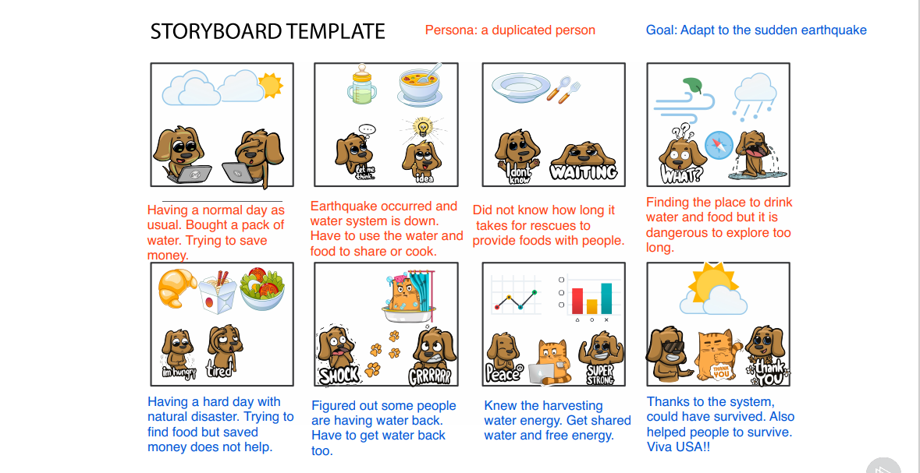

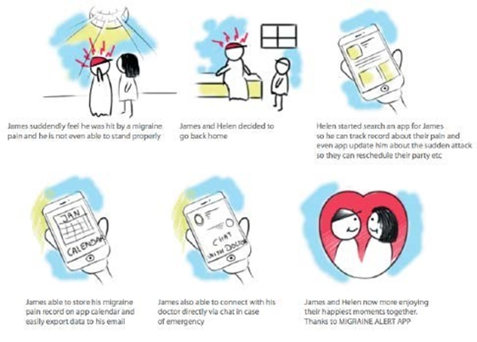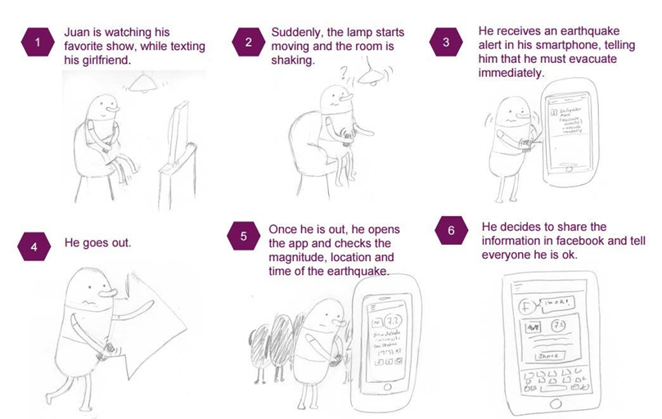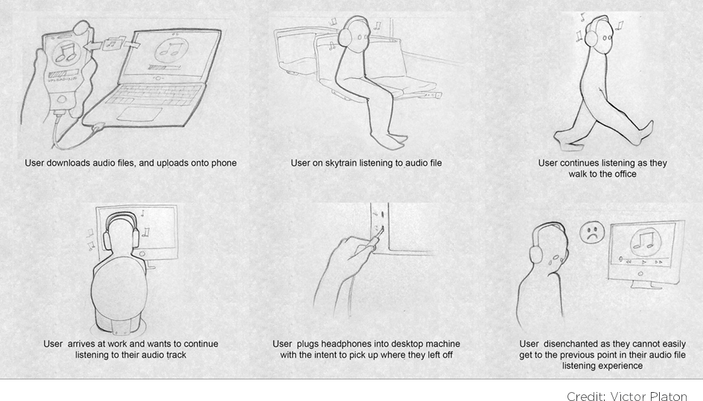

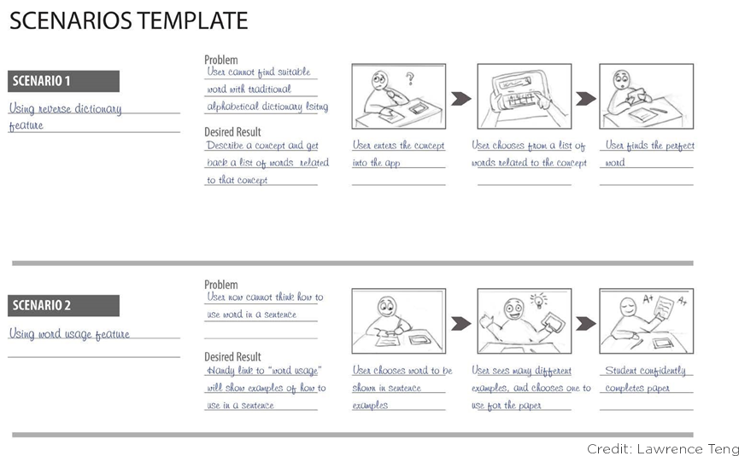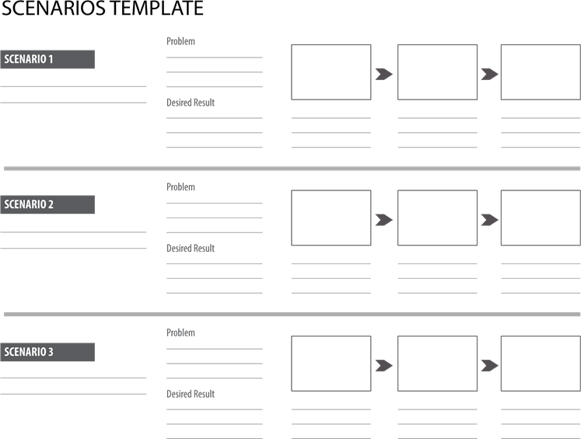

|  |  |  |
| --- | --- | --- |
| **[Persona name] – [Persona role / job title]** | | |
| *“No clean water. No healthy life.”* | · Key points about the person  · E.g. their role, their level of experience | **Needs to be able to:**  · Goals that the persona needs to complete  · For example they might be to find out some information, carry out a transaction or to complete a task  **Key questions:**  · Questions that the persona is likely to have  · For example, when do I need to do something by? |

|  |  |
| --- | --- |
| **Scenario [no.] – [scenario name]** | |
| Description of the scenario. Should specify the context in which the scenario has arisen, including the motivation for using the website / software / system and the desired goal.  There should be scenarios covering all of the main goals - concentrate on ‘Sunny day’ scenarios (i.e. most common usage with no hiccups) and prioritise so that the most important or initial scenarios are sketched out first. | **Importance:**  **Frequency:** |

|  |  |  |  |
| --- | --- | --- | --- |
| **Scenario steps** | **Comments** | **Outstanding questions** | **Required functionality** |
| Steps for the user journey. The user journey should be end-to-end so might include multiple uses of the website / software and might involve other interactions, such as telephoning the company. | Include any extra comments that might be necessary to help show what would take place. For example, whether a link will open in a new window or some more details about how something will be displayed. | Include any outstanding questions that should be looked into. For example, will someone know to go here? Will James be able to access his email account at work etc… | Functionality that needs to be made available to users to accomplish this scenario. |
| Try to keep descriptions short and to the point, but cover enough to work out what is going on. Making descriptions too verbose makes the scenarios long and more intimidating for readers. |  |  | Try to cover all the functionality required for the desired user journey |
| Try to include not just what happens, but also how it makes the persona feel and how it impacts their experience. |  |  | You don’t need to go in to a great deal of detail. For example, ‘Remove candidates from the list by selecting the desired candidates and hitting the remove button’ is too much detail – remember to concentrate on ‘what is required’ not necessarily how it might work |
| Try to concentrate on the ‘what’, not necessarily the ‘how’. For example, “Suzanne adds a candidate to her list” is sufficient, you don’t need to go in to detail around exactly how she does this. |  |  |  |

JOURNEY MAP TEMPLATE